BRAYDEN WICKEL
North Vancouver, BC | +1 208-509-8811 | wickelb@gmail.com | LinkedIn | Portfolio
EXPERT TECHNICAL SUPPORT REPRESENTATIVE
Summary of Qualifications
- Over 6 years’ experience supporting functionality-related incidents, onboarding, and access requests from customers and clients in enterprise and consumer product environments.
- Familiar with connectivity, performance, and provisioning difficulties related to onsite and cloud-based servers.
- Consistent with ticket compliance in a variety of ticketing systems, including linked documentation and attachments.
- Effective at engaging in root cause analysis to critically evaluate necessary steps to complete complex and unique requests.
- An organized team player, known for rapidly providing relevant technical documentation and adaptive suggestions for challenges peers face throughout the day.
- Certified in Network+, Security+. Hands-on experience with log management and backup/restore for Windows and Linux servers.
CORE COMPETENCIES
Active Directory | Machine Performance | Microsoft Office 365 | Detail-oriented | Intune & Azure
Ticket Management | Critical Thinking | User Onboarding | Team Collaboration | Patience & Empathy
EXPERIENCE
Arthur J. Gallagher & Co | Rolling Meadows, IL
Service Desk Specialty Support II (Remote) | 03/2022 – Present
- Provided white-glove support to the top 200 performers (VIPs) of a company of 65,000+ employees.
- Onboarded thousands of new employees migrating to our systems as part of mergers & acquisitions.
- Imaged hundreds of laptops and processed hardware orders for laptop & component replacement.
- Consistently produced top 1% metrics for ticket compliance, call handling, and attendance scores month-by-month.
- Monitored all communication channels such as Teams, email, voicemail, and the ticketing system to ensure timely responses to all clients.
- Assisted teammates with incoming escalations, increased workloads, and any interactions they could not complete.
- Embraced challenges in the form of various IT projects as needed by leadership and teammates.
- Resolved Citrix virtual desktop, xenapp, and access issues using Citrix Director and Active Directory.
- Streamlined the introduction of Azure Virtual Desktops into the enterprise.
- Implemented, configured, and supported various multiplatform services such as Intune MAM, mobile and desktop Jabber softphone, mobile IAM self-provisioning services at the endpoint and within web-based consoles.
- Installed and configured a multitude of applications onto Windows endpoints including but not limited to Adobe Acrobat, Office 2016, Office 365, cloud-based add-ins to integrate services such as OneDrive, Citrix Sharefile, PowerBI, Sharepoint, and enterprise-proprietary software.
Computer Task Group, Inc. | Boulder, CO
Service Desk Analyst (Remote) | 03/2020 – 08/2021
- Strived for rapid returns to productivity for healthcare company employees by closely following a knowledge base and support process.
- Effectively provided support for ID Management, global address lists, outage handling, incidents, and requests.
- Resolved a wide range of hardware issues for devices such as PCs / Macs, printers, docking stations, and other peripherals.
- Assisted with functionality and access to an abundance of enterprise tools, including (but not limited to) VPN, Network drives, MS Office / Exchange tools, Avaya 1X Workplace/Agent, Verint, Peoplesoft, Mainframe (Reflection Workspace).
CERTIFICATIONS & AWARDS
CompTIA Network+ Ce Certificate | 2023
CompTIA Security+ Ce Certificate | 2022
Cyber SkyLine - NCL Fall 2023 Individual & Team Game | 2023
Cyber SkyLine - NCL Spring 2024 Individual & Team Game | 2024
Cyber SkyLine - NCL Fall 2024 Individual & Team Game | 2024
Microsoft - Create and manage automated processes by using Power Automate | 2024
freeCodeCamp – Responsive Web Design - View | 2025
ProofPoint - Certified Email Authentication Specialist 2025 - View | 2025
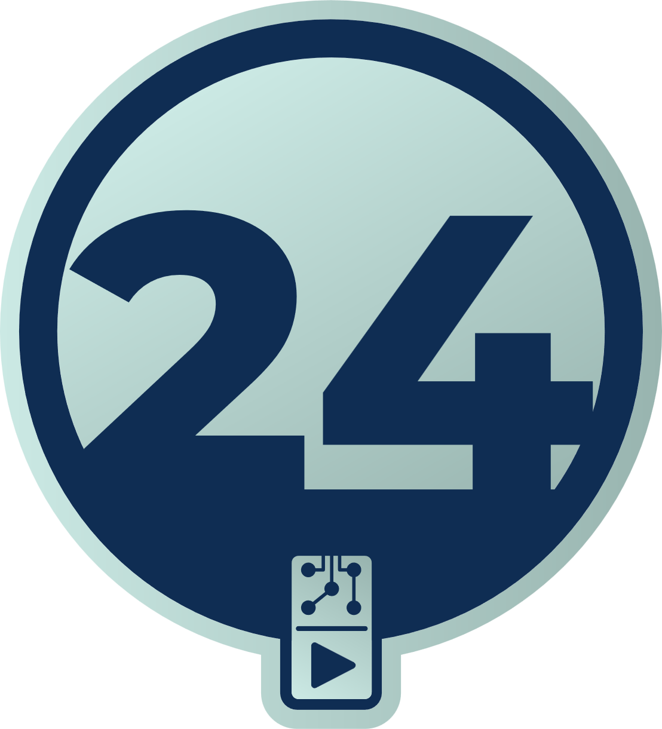  NCAE 2024 Competitor | 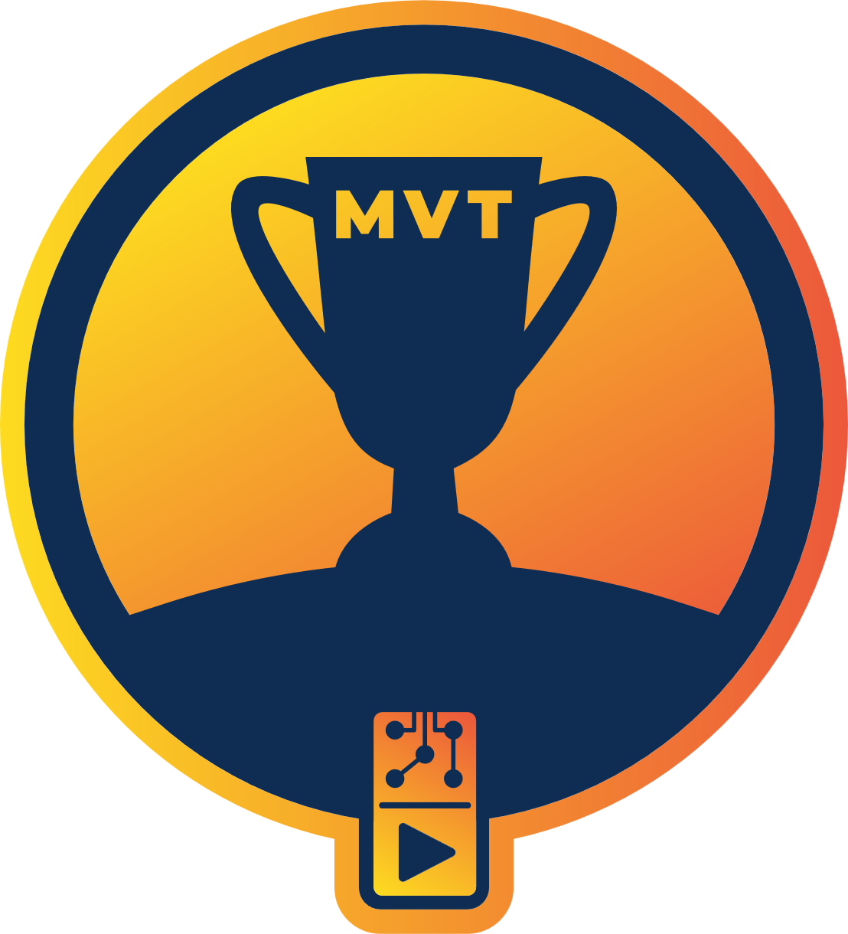  Most Valuable Teammate NCAE 2024 | 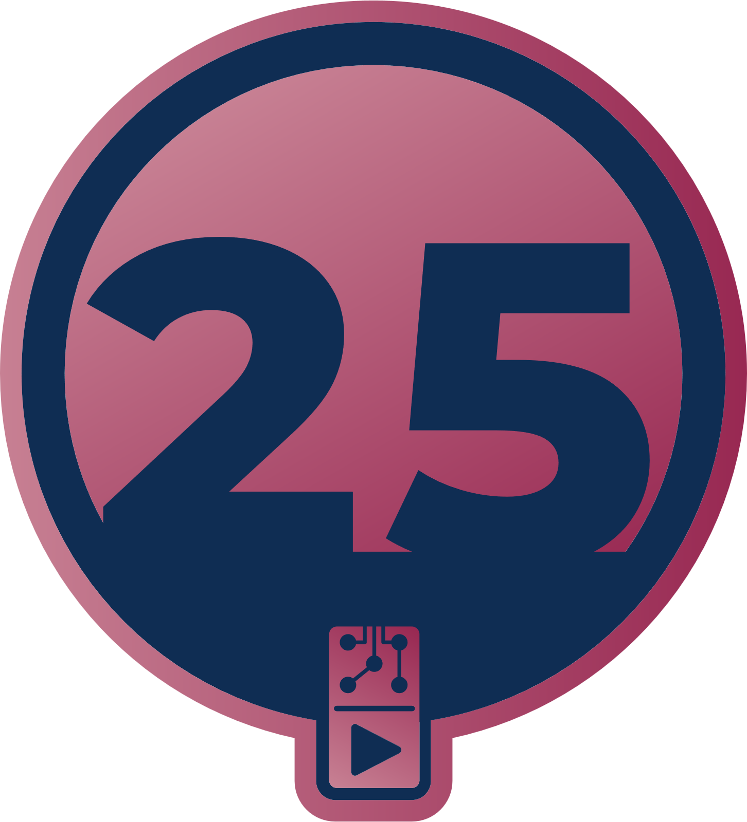  NCAE 2025 Competitor | Most Valuable Teammate NCAE 2025
INFORMATION TECHNOLOGY EDUCATION
DeVry University | Denver Area, CO
Bachelors in Cyber Security Programming | 2022 - 2025

DeVry University | Denver Area, CO
Associates in Information Systems & Programming With Honors | View Credential | 2022 - 2024

DeVry University | Denver Area, CO
Undergraduate Certificate – Programming Essentials  - SQL  - C#  - Python Object Oriented Programming | 2023
LeaderQuest, an ACI Learning Company | Centennial, CO
Information System Analyst (ISA) Certificate Program | 2022
- CompTIA Security+
- EC-Council Certified Network Defender (CND)
- EC-Council Certified Ethical Hacker (CEH)
INTERNSHIPS/VOLUNTEER WORK
Pathways Serious Mental Illness Society | North Vancouver, BC
Office Admin Assistant | 5/2025 – Present
- Maintained organization, intake, and structure of sensitive documentation in secure storage.
- Contributed to developing a functional platform for membership management through Salesforce CRM.
ClickSafe Intelligence | Portland, OR
Investigating Child Exploitation and Safety Features of Minecraft | 6/2024 – 10/2024
- Contributed to over 100 hours of research highlighting the vulnerabilities children face when playing Minecraft online via extensive notetaking and recording.
- Proofread and co-signed the following reports:
  - Building Blocks: Investigating Child Exploitation and Safety Features of Minecraft
  - Parent Safety Guide: Minecraft Java & Bedrock Edition
PROFESSIONAL ASSOCIATIONS
Student Member in good standing, Institute of Electrical and Electronics Engineers (IEEE) | 2025

